VS Code Directory Structure for Project – NINETRIANGLESAPP
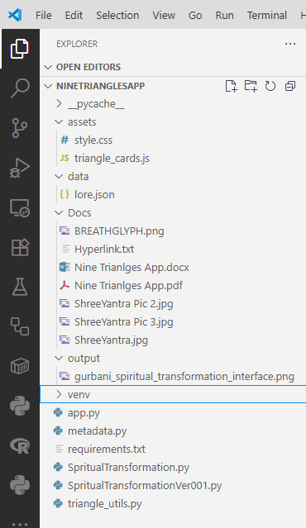
In project root
assets/style.css
/* === Core Layout === */
body {
margin: 0;
font-family: 'Segoe UI', sans-serif;
background: linear-gradient(to bottom right, #0f0f0f, #1a1a1a);
color: #e0e0e0;
}

/* === Symbolic Card Container === */
.card {
border-radius: 12px;
padding: 1.2rem;
margin: 1rem;
background: rgba(255, 255, 255, 0.05);
-webkit-backdrop-filter: blur(8px); /* Safari support */
backdrop-filter: blur(8px);
box-shadow: 0 0 12px rgba(0, 0, 0, 0.4);
transition: transform 0.3s ease, box-shadow 0.3s ease;
cursor: pointer;
}

/* === Hover Interactivity === */
.card:hover {
transform: scale(1.03);
box-shadow: 0 0 18px rgba(255, 255, 255, 0.2);
}

/* === Elemental Themes === */
.card[data-element="Air"] { border-left: 4px solid #a8e6cf; }
.card[data-element="Fire"] { border-left: 4px solid #ff8b94; }
.card[data-element="Water"] { border-left: 4px solid #69b7ff; }
.card[data-element="Earth"] { border-left: 4px solid #c3b091; }
.card[data-element="Aether"] { border-left: 4px solid #d1c4e9; }
.card[data-element="Metal"] { border-left: 4px solid #b0bec5; }
.card[data-element="Wood"] { border-left: 4px solid #aed581; }
.card[data-element="Light"] { border-left: 4px solid #fff176; }
.card[data-element="Shadow"] { border-left: 4px solid #616161; }

/* === Lore Text Styling === */
.lore {
font-style: italic;
font-size: 0.95rem;
color: #cccccc;
margin-top: 0.5rem;
}

/* === Communion Seeker Overlay === */
#communion-seeker {
position: fixed;
bottom: 2rem;
right: 2rem;
background: radial-gradient(circle, #222, #000);
border: 2px solid #888;
border-radius: 50%;
width: 80px;
height: 80px;
display: flex;
align-items: center;
justify-content: center;
color: #fff;
font-size: 0.75rem;
text-align: center;
animation: pulse 3s infinite;
}

/* === Pulse Animation === */
@keyframes pulse {
0% { box-shadow: 0 0 0px rgba(255,255,255,0.2); }
50% { box-shadow: 0 0 12px rgba(255,255,255,0.4); }
100% { box-shadow: 0 0 0px rgba(255,255,255,0.2); }
}

assets/triangle_cards.js

document.querySelectorAll("polygon").forEach(poly => {
poly.addEventListener("click", () => {
const symbol = poly.getAttribute("title");
const card = document.getElementById("symbolic-card");
card.innerHTML = `<h3>${symbol}</h3><p>${getLore(symbol)}</p>`;
});
});

document.addEventListener("DOMContentLoaded", function() {
if (!CSS.supports("backdrop-filter", "blur(5px)")) {
document.querySelectorAll(".symbolic-card").forEach(card => {
card.style.backgroundColor = "rgba(255,255,255,0.2)";
});
}
});

function getLore(symbol) {
const loreMap = {
"Wisdom": "Clarity of thought and the breath of insight.",
"Courage": "The spark that ignites transformation.",
"Harmony": "Flowing unity and emotional resonance.",
"Structure": "Foundation, form, and sacred geometry.",
"Vision": "The unseen pattern behind all things.",
"Balance": "Precision, reflection, and inner alignment.",
"Flow": "Growth, adaptability, and creative expansion.",
"Truth": "Illumination, revelation, and integrity.",
"Mystery": "The unknown, the hidden, the fertile void."
};
return loreMap[symbol] || "Unknown symbol.";
}

data/lore.json

{
"triangles": [
{
"id": 1,
"name": "Triangle of Air",
"element": "Air",
"mantra": "Vayu Namah",
"symbol": "🌬️",
"lore": "Breath is the bridge between thought and form. Air carries the whisper of intention."
},
{
"id": 2,
"name": "Triangle of Fire",
"element": "Fire",
"mantra": "Agni Namah",
"symbol": "🔥",
"lore": "Fire transforms. It consumes illusion and reveals the radiant core of being."
},
{
"id": 3,
"name": "Triangle of Water",
"element": "Water",
"mantra": "Jala Namah",
"symbol": "💧",
"lore": "Water remembers. It flows through memory, emotion, and the sacred pulse of life."
},
{
"id": 4,
"name": "Triangle of Earth",
"element": "Earth",
"mantra": "Prithvi Namah",
"symbol": "🌍",
"lore": "Earth holds. It anchors the soul in form, offering stability and sacred geometry."
},
{
"id": 5,
"name": "Triangle of Aether",
"element": "Aether",
"mantra": "Akasha Namah",
"symbol": "✨",
"lore": "Aether is the unseen field. It binds all elements in communion and silence."
},
{
"id": 6,
"name": "Triangle of Metal",
"element": "Metal",
"mantra": "Loha Namah",
"symbol": "⚙️",
"lore": "Metal reflects. It is the mirror of karma, forged by discipline and clarity."
},
{
"id": 7,
"name": "Triangle of Wood",
"element": "Wood",
"mantra": "Vriksha Namah",
"symbol": "🌳",
"lore": "Wood grows. It spirals upward, connecting root to sky in sacred expansion."
},
{
"id": 8,
"name": "Triangle of Light",
"element": "Light",
"mantra": "Jyoti Namah",
"symbol": "🌟",
"lore": "Light reveals. It is the language of truth, illuminating the path of the seeker."
},
{
"id": 9,
"name": "Triangle of Shadow",
"element": "Shadow",
"mantra": "Chhaya Namah",
"symbol": "🌑",
"lore": "Shadow conceals. It is the womb of transformation, where the unseen prepares to emerge."
}
]
}

output/gurbani_spiritual_transformation_interface.png

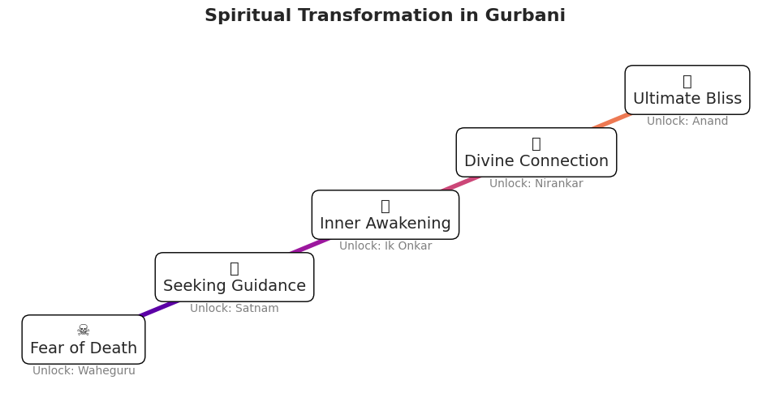

app.py ( inside project root)

import streamlit as st
from triangle_utils import isosceles_triangle, svg_triangle, render_symbolic_card
from metadata import load_triangle_meta

# Load triangle metadata
TRIANGLE_META = load_triangle_meta()

# Page config
st.set_page_config(layout="wide")

# Inject CSS
def local_css(file_name):
try:
with open(file_name, encoding="utf-8") as f:
st.markdown(f"<style>{f.read()}</style>", unsafe_allow_html=True)
except FileNotFoundError:
st.error(f"Missing {file_name}")

local_css("assets/style.css")

# Inject JS
try:
with open("assets/triangle_cards.js") as f:
st.markdown(f"<script>{f.read()}</script>", unsafe_allow_html=True)
except FileNotFoundError:
st.error("Missing triangle_cards.js in assets folder.")

# View selector
view = st.radio("Choose view", ["Disintegrated", "Integrated", "Symbolic"])

# Render SVG triangles
if view in ["Disintegrated", "Integrated"]:
svg_elements = []
for meta in TRIANGLE_META:
center = (200 + meta["id"] * 20, 200 + meta["id"] * 10) if view == "Disintegrated" else (300, 300)
points = isosceles_triangle(center=center, rotation=meta["rotation"])
svg_elements.append(svg_triangle(points, meta["symbol"], meta["element"]))

st.markdown(f"""
<svg width="600" height="600">
{' '.join(svg_elements)}
</svg>
""", unsafe_allow_html=True)

# Render symbolic lore cards
elif view == "Symbolic":
st.markdown("### 🧬 Symbolic Lore of the Nine Triangles")
for meta in TRIANGLE_META:
st.markdown(render_symbolic_card(meta), unsafe_allow_html=True)

st.markdown("""
<div id="symbolic-card" class="symbolic-card">
<h3>Click a triangle to reveal its lore</h3>
</div>
""", unsafe_allow_html=True)

metadata.py (inside directory root)

import json
import os

def load_triangle_meta():
path = os.path.join("data", "lore.json")
try:
with open(path, "r", encoding="utf-8") as f:
content = f.read()
if not content.strip():
raise ValueError("Empty JSON file.")
raw = json.loads(content)

# Extract triangle list
meta = raw.get("triangles", [])
if not isinstance(meta, list):
raise ValueError("Expected 'triangles' to be a list.")

# Add rotation
for i, item in enumerate(meta):
item["rotation"] = i * 40

return meta

except (FileNotFoundError, ValueError, json.JSONDecodeError) as e:
print(f"⚠️ Failed to load lore.json: {e}. Falling back to default metadata.")
return default_triangle_meta()
def default_triangle_meta():
symbols = [
("Wisdom", "Air", "Clarity of thought and the breath of insight."),
("Courage", "Fire", "The spark that ignites transformation."),
("Harmony", "Water", "Flowing unity and emotional resonance."),
("Structure", "Earth", "Foundation, form, and sacred geometry."),
("Vision", "Aether", "The unseen pattern behind all things."),
("Balance", "Metal", "Precision, reflection, and inner alignment."),
("Flow", "Wood", "Growth, adaptability, and creative expansion."),
("Truth", "Light", "Illumination, revelation, and integrity."),
("Mystery", "Shadow", "The unknown, the hidden, the fertile void.")
]

return [
{
"id": i,
"symbol": sym,
"element": elem,
"lore": lore,
"rotation": i * 40
}
for i, (sym, elem, lore) in enumerate(symbols)
]

Requirements.txt

streamlit==1.33.0
numpy==1.26.0
sympy==1.12
pandas==2.2.2
matplotlib==3.8.4
seaborn==0.13.2
streamlit-elements==0.2.0

SpiritualTransformation.py

import matplotlib.pyplot as plt
import seaborn as sns
import numpy as np
import os
from matplotlib import font_manager

# Optional: Load a Unicode-friendly font if available
font_path = "Symbola.ttf"
font_prop = None

if os.path.exists(font_path):
font_prop = font_manager.FontProperties(fname=font_path)
else:
print("Symbola.ttf not found. Using default font.")

# Set style for aesthetics
sns.set_style("whitegrid")
plt.rcParams.update({'font.size': 12, 'font.family': 'DejaVu Sans'})

# Create output directory
output_dir = "output"
os.makedirs(output_dir, exist_ok=True)

# Define stages of spiritual transformation
stages = [
"Fear of Death",
"Seeking Guidance",
"Inner Awakening",
"Divine Connection",
"Ultimate Bliss"
]
progress = np.arange(1, len(stages) + 1)
colors = sns.color_palette("plasma", len(stages))

# Define symbolic glyphs and mantras
symbols = ["☠", "🔍", "💡", "🔱", "🕉"]
mantras = ["Waheguru", "Satnam", "Ik Onkar", "Nirankar", "Anand"]

# Create figure and axis
fig, ax = plt.subplots(figsize=(12, 6))

# Plot gradient path
for i in range(len(progress) - 1):
ax.plot([progress[i], progress[i + 1]], [i, i + 1], color=colors[i], linewidth=4)

# Add symbolic badges and mantra unlocks
for i, (stage, symbol, mantra) in enumerate(zip(stages, symbols, mantras)):
ax.text(
progress[i], i,
f"{symbol}\n{stage}",
fontsize=14,
ha='center',
va='center',
bbox=dict(facecolor='white', edgecolor='black', boxstyle='round,pad=0.5'),
fontproperties=font_prop if font_prop else None
)
ax.text(
progress[i], i - 0.5,
f"Unlock: {mantra}",
fontsize=10,
ha='center',
va='center',
color='gray'
)

# Final touches
ax.set_xlim(0.5, len(stages) + 0.5)
ax.set_ylim(-1, len(stages))
ax.axis('off')
plt.title("Spiritual Transformation in Gurbani", fontsize=16, weight='bold')

# Save visualization
output_path = os.path.join(output_dir, "gurbani_spiritual_transformation_interface.png")
plt.savefig(output_path, bbox_inches='tight')
plt.close()

print(f"Spiritual transformation interface saved as '{output_path}'")

# import matplotlib.pyplot as plt
# import seaborn as sns
# import numpy as np
# import os
# from matplotlib import font_manager

# # Optional: Load a Unicode-friendly font if available
# try:
# font_path = "Symbola.ttf" # Replace with actual path if installed
# font_prop = font_manager.FontProperties(fname=font_path)
# except:
# font_prop = None # Fallback to default

# # Set style for aesthetics
# sns.set_style("whitegrid")
# plt.rcParams.update({'font.size': 12, 'font.family': 'DejaVu Sans'})

# # Create output directory
# output_dir = "output"
# os.makedirs(output_dir, exist_ok=True)

# # Define stages and symbolic elements
# stages = ["Fear of Death", "Seeking Guidance", "Inner Awakening", "Divine Connection", "Ultimate Bliss"]
# progress = np.arange(1, len(stages) + 1)
# colors = sns.color_palette("plasma", len(stages))
# symbols = ["☠", "🔍", "💡", "🔱", "🕉"]
# mantras = ["Waheguru", "Satnam", "Ik Onkar", "Nirankar", "Anand"]

# # Create figure
# fig, ax = plt.subplots(figsize=(12, 6))

# # Plot transformation path
# for i in range(len(progress) - 1):
# ax.plot([progress[i], progress[i + 1]], [i, i + 1], color=colors[i], linewidth=4)

# # Add symbolic badges and mantras
# for i, (stage, symbol, mantra) in enumerate(zip(stages, symbols, mantras)):
# ax.text(progress[i], i, f"{symbol}\n{stage}", fontsize=14, ha='center', va='center',
# bbox=dict(facecolor='white', edgecolor='black', boxstyle='round,pad=0.5'),
# fontproperties=font_prop)
# ax.text(progress[i], i - 0.5, f"Unlock: {mantra}", fontsize=10, ha='center', va='center', color='gray')

# # Final touches
# ax.set_xlim(0.5, len(stages) + 0.5)
# ax.set_ylim(-1, len(stages))
# ax.axis('off')
# plt.title("Spiritual Transformation in Gurbani", fontsize=16, weight='bold')

# # Save visualization
# output_path = os.path.join(output_dir, "gurbani_spiritual_transformation_interface.png")
# plt.savefig(output_path, bbox_inches='tight')
# plt.close()

# print(f"Spiritual transformation interface saved as '{output_path}'")

triangle_utils.py ( inside directory root)

import numpy as np

def isosceles_triangle(base=100, height=150, center=(200, 200), rotation=0):
cx, cy = center
points = np.array([
[cx - base / 2, cy],
[cx + base / 2, cy],
[cx, cy - height]
])
theta = np.radians(rotation)
rot_matrix = np.array([
[np.cos(theta), -np.sin(theta)],
[np.sin(theta), np.cos(theta)]
])
rotated = np.dot(points - [cx, cy], rot_matrix) + [cx, cy]
return rotated.tolist()

def svg_triangle(points, symbol, element, opacity=0.6):
p_str = " ".join([f"{x},{y}" for x, y in points])
css_class = f"triangle-{element.lower()}"
return f'<polygon points="{p_str}" class="{css_class}" opacity="{opacity}" title="{symbol}" />'

def render_symbolic_card(meta):
return f"""
<div class="symbolic-card">
<h3>{meta['symbol']} ({meta['element']})</h3>
<p>{meta['lore']}</p>
</div>
"""

